**DEPARTMENT PART**

**Head Clerk**

**“Application Receipt by Head Clerk”**

**Step 1:**

Login as “**Head Clerk**” in Service plus web portal.

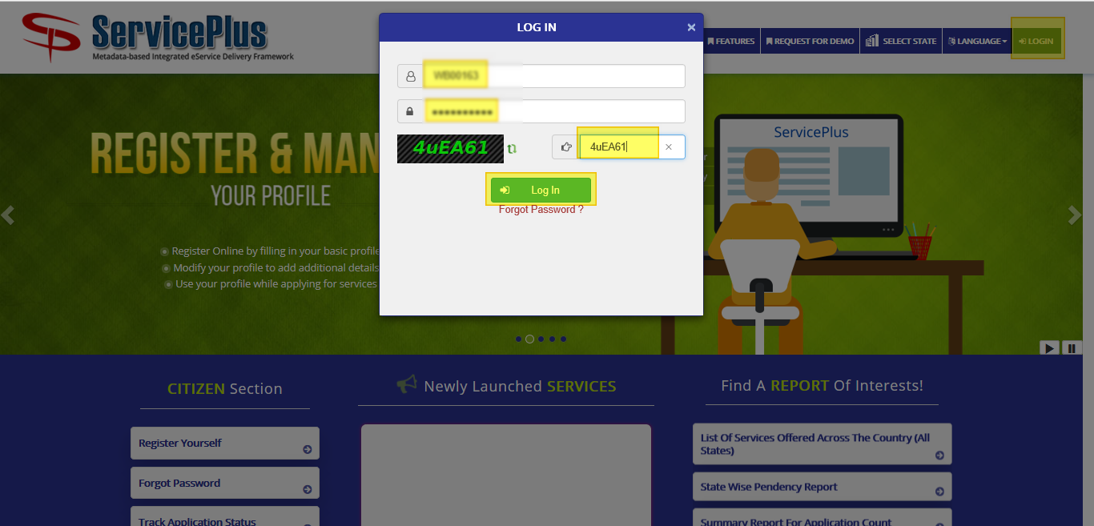

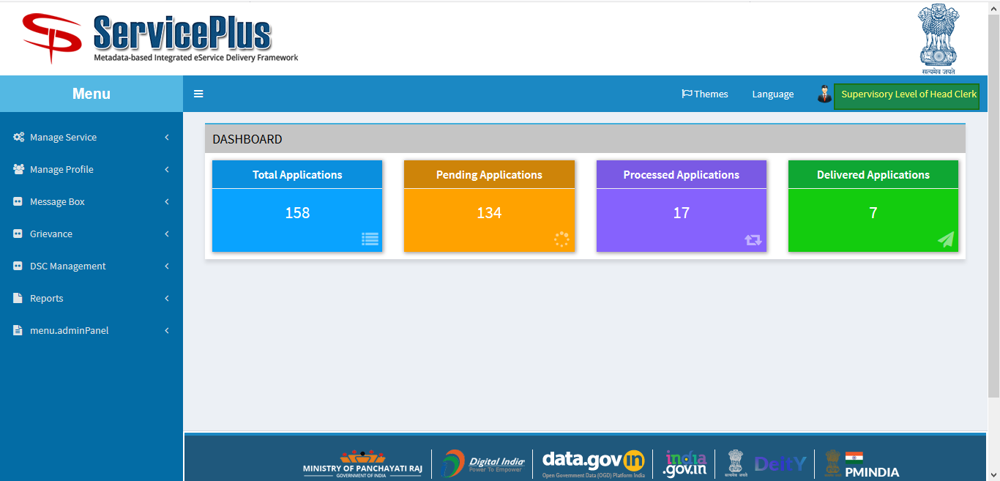

**Step 2:**

Now Go to **“Message Box”** and select **“Inbox”**.

In Inbox select the service **“Application for Rent payment of Flats in Bidhannagar Municipal Corporation Area”** and select the task **“Verification Application”** and select **“Get Data”.**

If got **App Ref No.** the application can be searched specifically.

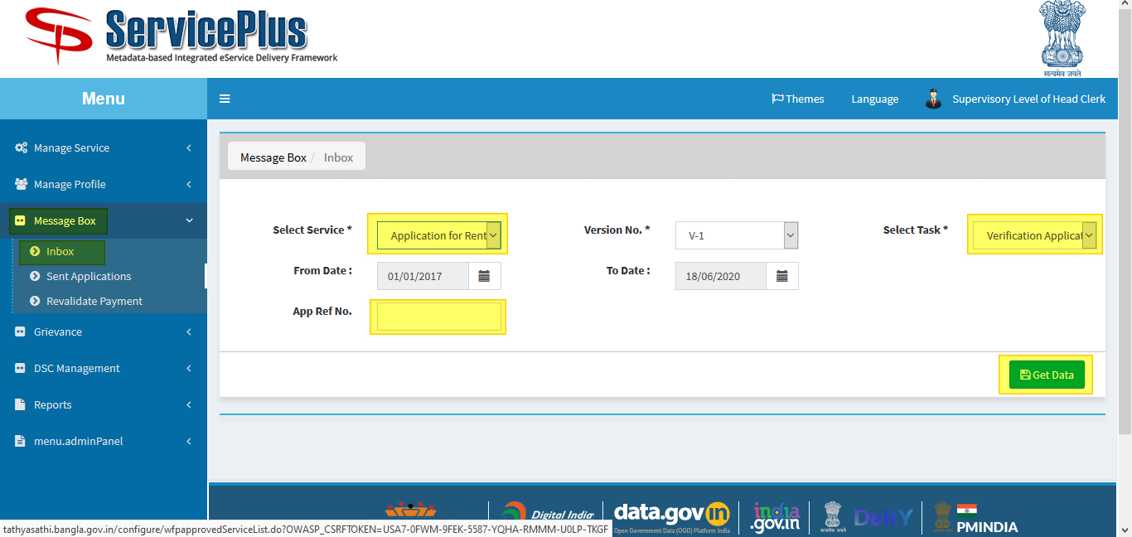

**Step 3:**

If **“Application Number”** selected the details of the application can be seen.

Select **“Pull”** to take action.

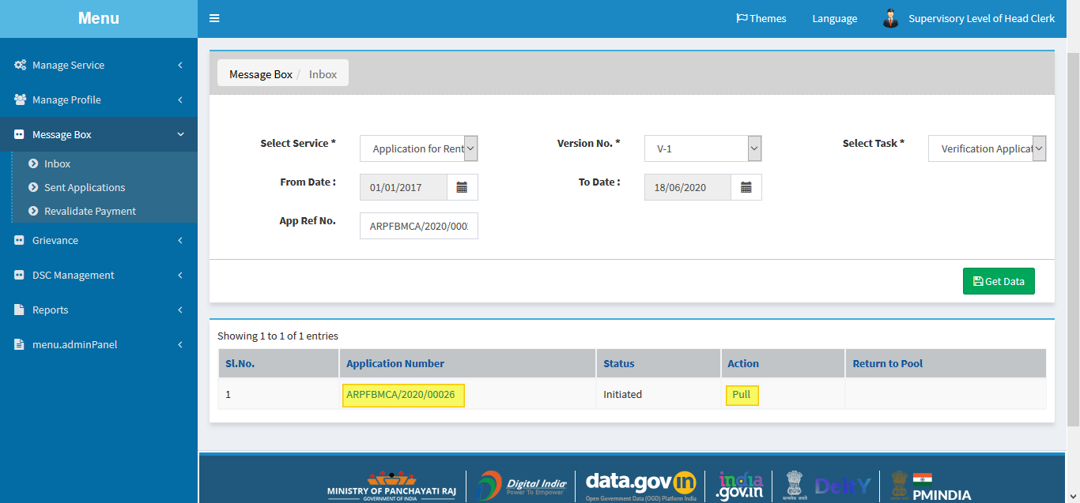

**Step 4:**

Select **“View Processing History”** to see the history of the application.

Verification of form can be done by Head Clerk by taking action in three steps to **Reject**, **Deliver** or **Forward**.

* By selecting reject and submit it directly rejects the application.
* By Selecting Deliver you may have to update the database by clicking the button **“Update Database”** to enable submit button.
* Forward to **“Application Submission Shortfall”** which leads to re checking of form.

And if **“Approved Application by Head Clerk”** give remarks and submit.

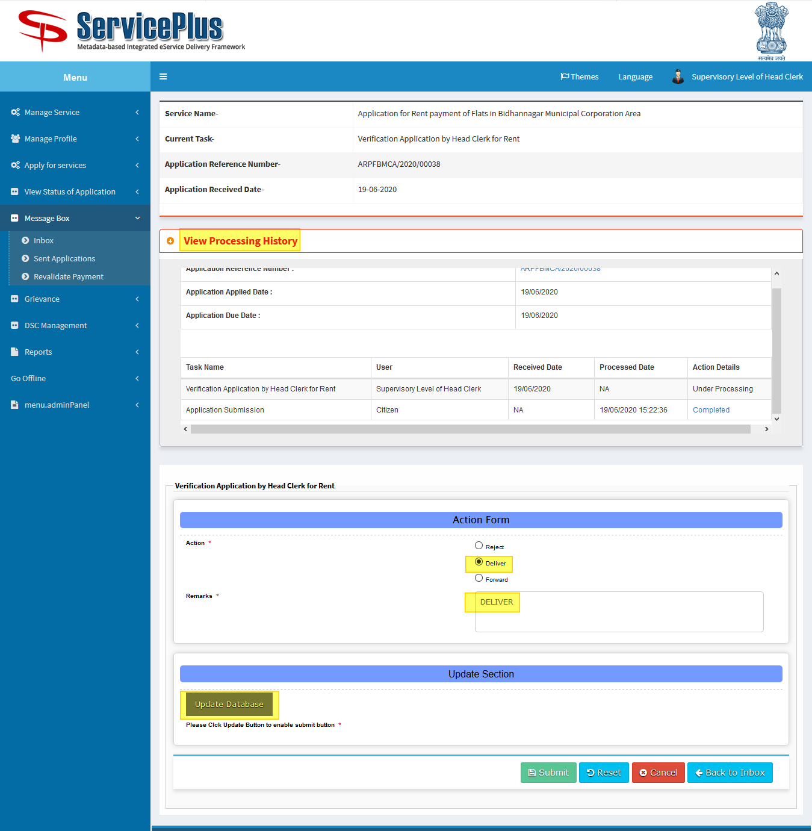

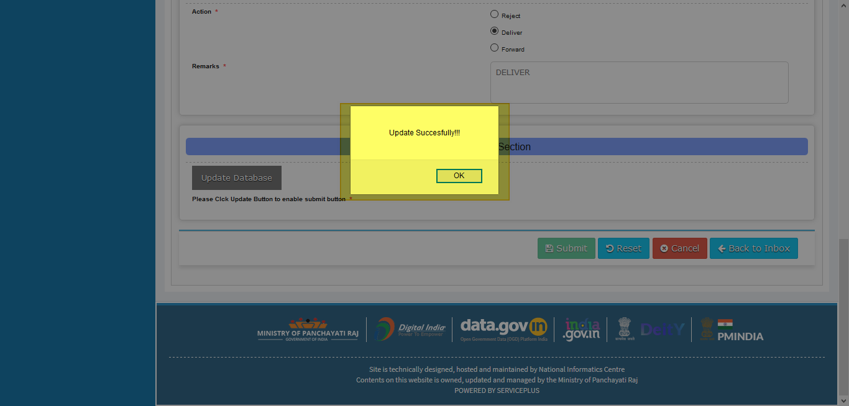

**Step 5:**

Now the Submit Button is enable to submit.

And by submitting it’s delivered.

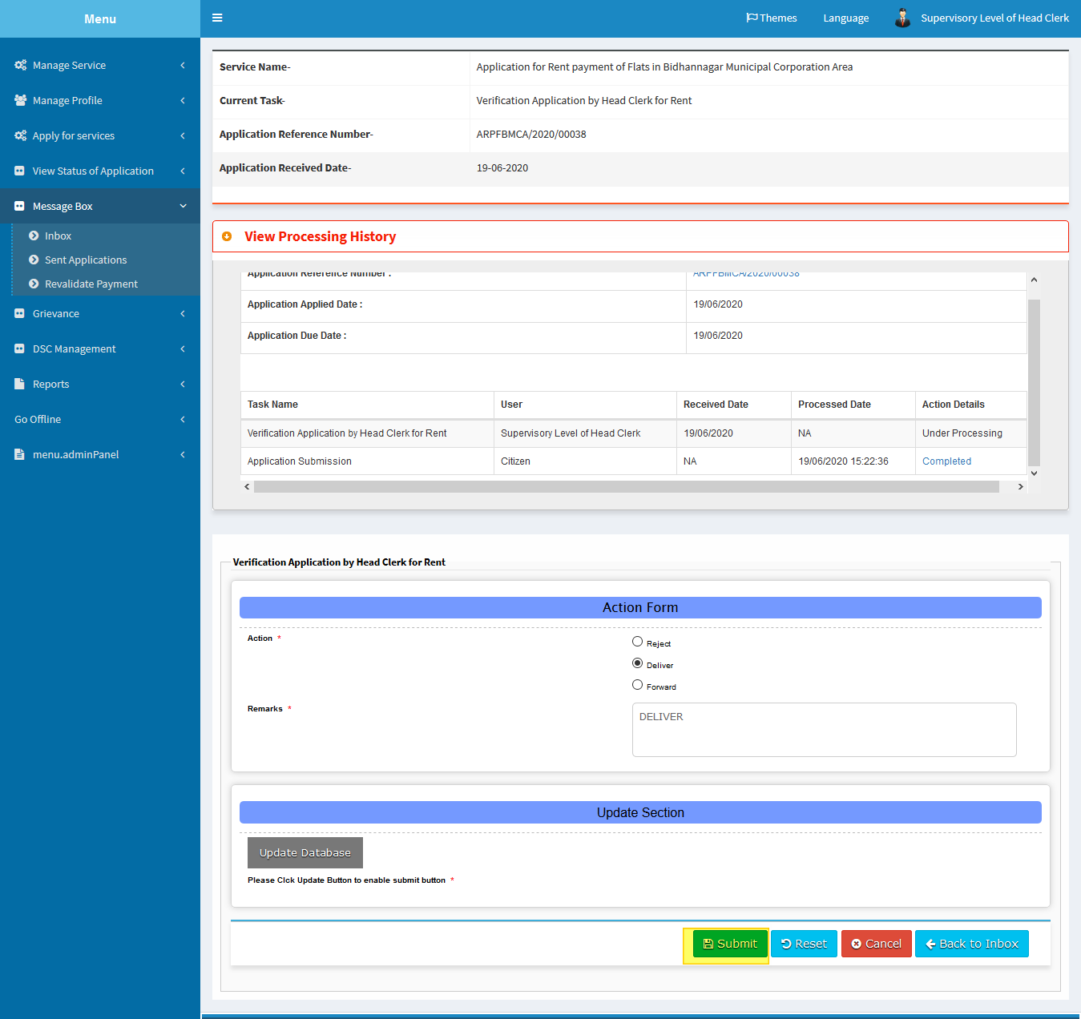

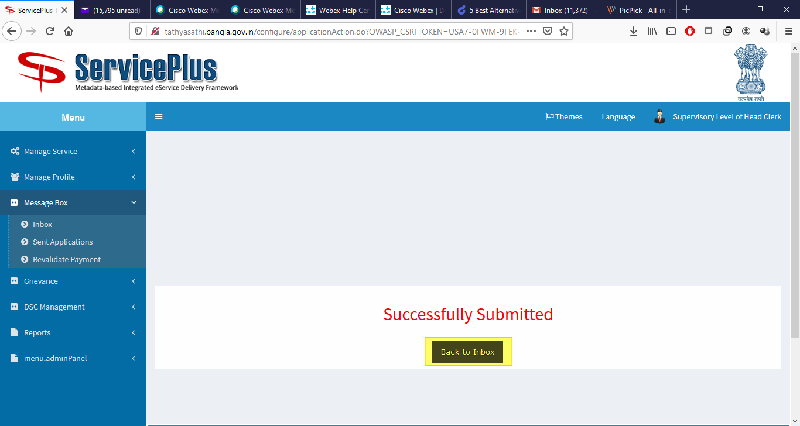

**SHORTFALL SELECTED**

